Write a shell script validate_results.sh that reads student data from marks.txt.Each line contains:RollNo, Name, Marks1,Marks2,Marks3Your script should:
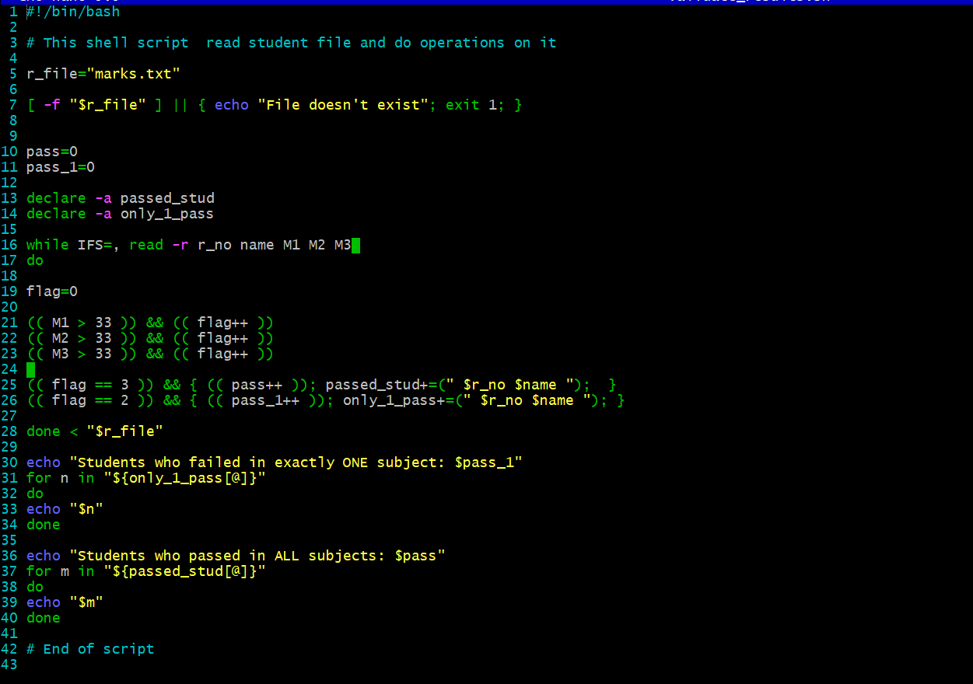
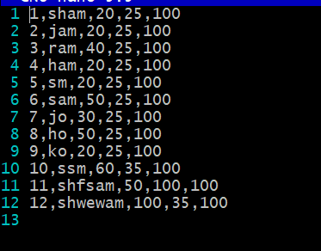
• Print students who failed in exactly ONE subject
• Print students who passed in ALL subjects
• Print the count of students in each categoryPassing marks for each subject is 33.Use loops, conditionals, and arithmetic operations.
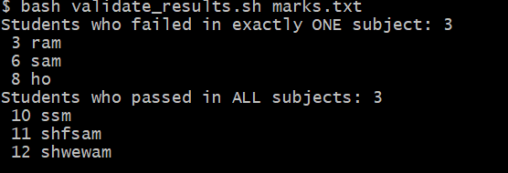

Explanation: So above script use condition, loops and check marks.txt file and print student names who passed in only one subject, student passed in all 3 subjects. Its won’t print student name who failed in 2. And handles error as well. I used array to make it easy to store and print students with while and for loop. Also used delimiter as , to read file properly. In terms of expiration used (()) brackets instead of expr command, which is clean and concise.

